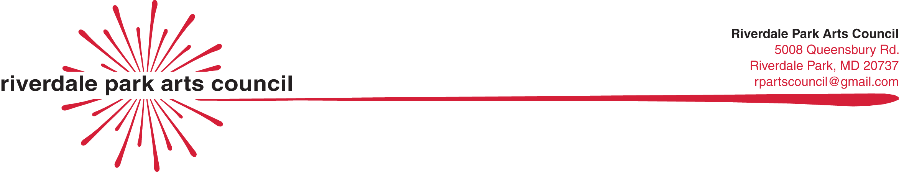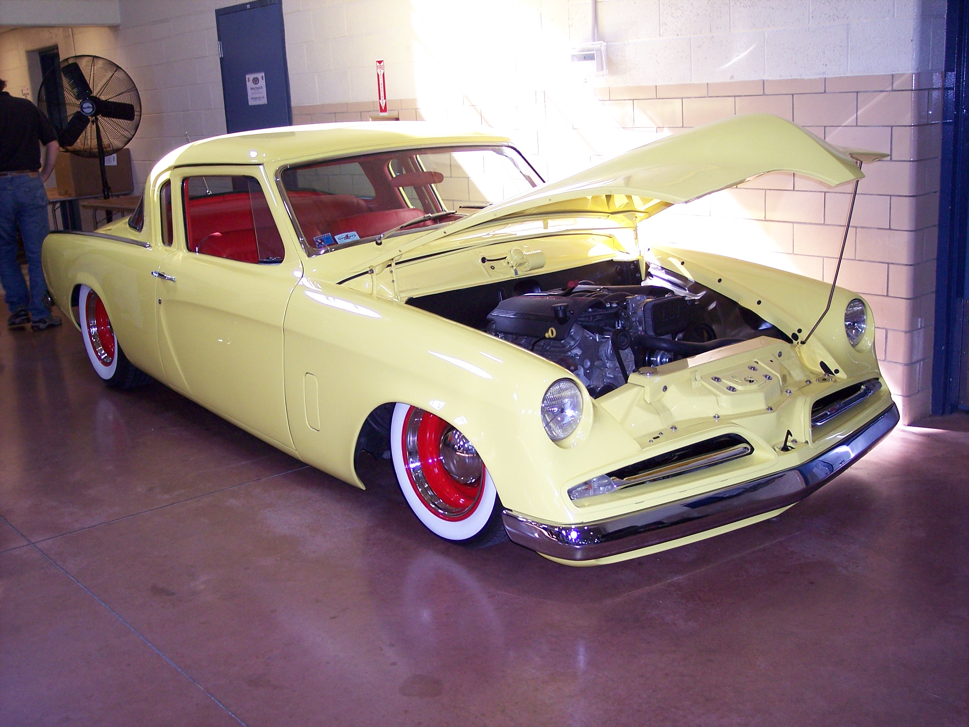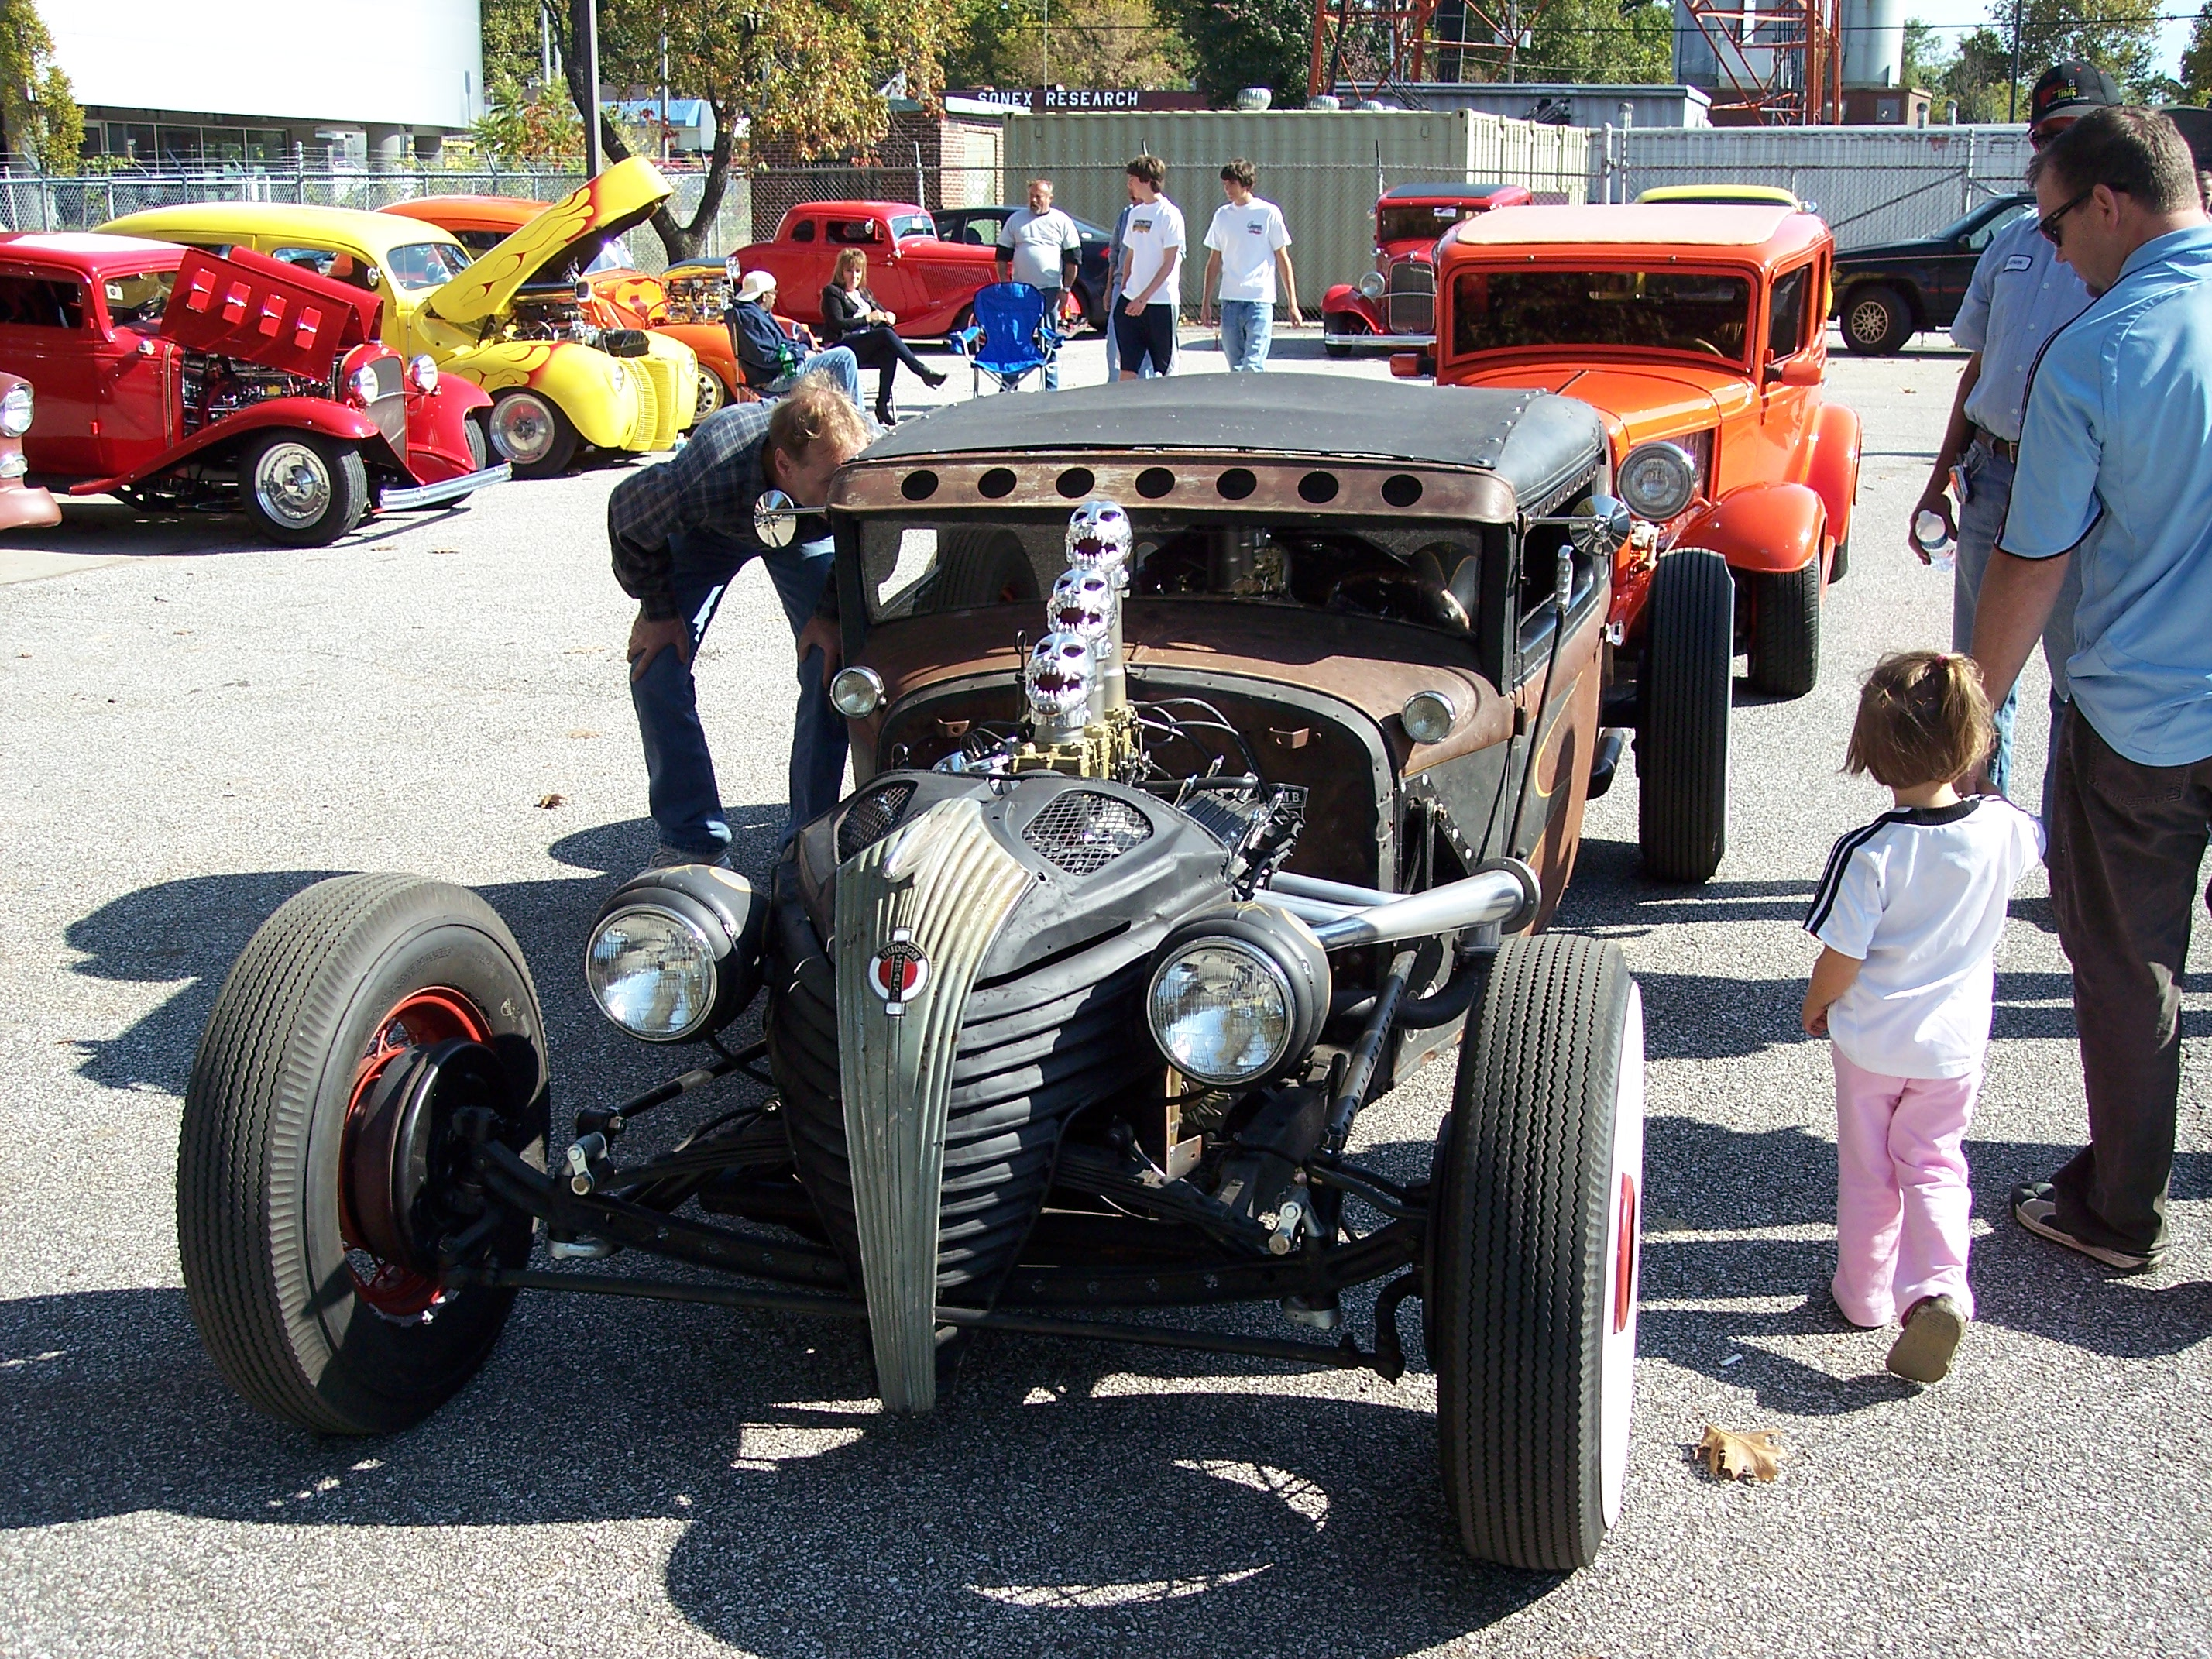
Riverdale Park ArtsFest2014
CALL FOR VINTAGE VEHICLES

Fill out this application and email it to rpartscouncil@gmail.com or mail it to Riverdale Park Arts Council, 5008 Queensbury Rd, Riverdale Park, MD 20737. For more info, contact 301-502-1243.
Applications due by Thursday, May 1 – spacing may not be available after this date.

Reserve your space now for the 7th annual Riverdale Park ArtsFest. Artists, Crafters, Authors and Musicians from our diverse community and invited to showcase and sell their original work during an outdoor music and arts celebration that includes displays, demonstrations, kids’ events, good food and great live music. It is a rain or shine event.
This year we also inviting drivers/riders of vintage vehicles to display their restored rides. A three-judge panel will vote on three “Best of” categories. Reserve your space now by completing this application form.

NO FEE APPLICATION FORM
Name
Address

Cell
Email
Website

ArtsFest2014 Sunday,
May 4, 2014 Riverdale Park
Town Center
11am-5pm
Year__________ Make ________________

Model_________ HP _________________

Category: Classic Hot Rod Pick Up Bike

Highlights ________________________
________________________________

Vintage Vehicles and Motorcycles will be displayed along Queensbury Rd. & Lafayette Rd.
Core Show Hours: Noon to 4 pm

